

***School of Mechanical & Manufacturing Engineering (SMME),***

***National University of Science and Technology (NUST),***

***Sector H-12, Islamabad***

Program: BE-Aerospace Section: AE-01

Session: Fall 2023 Semester: 1st

Course Title: Fundamentals of Programming (CS-109)

**Assignment:**

***Name: Anzish Fatima***

***CMS:*** 464627

Question:

Write a C++ code to make TIC TAC TOE game.

**Program:**

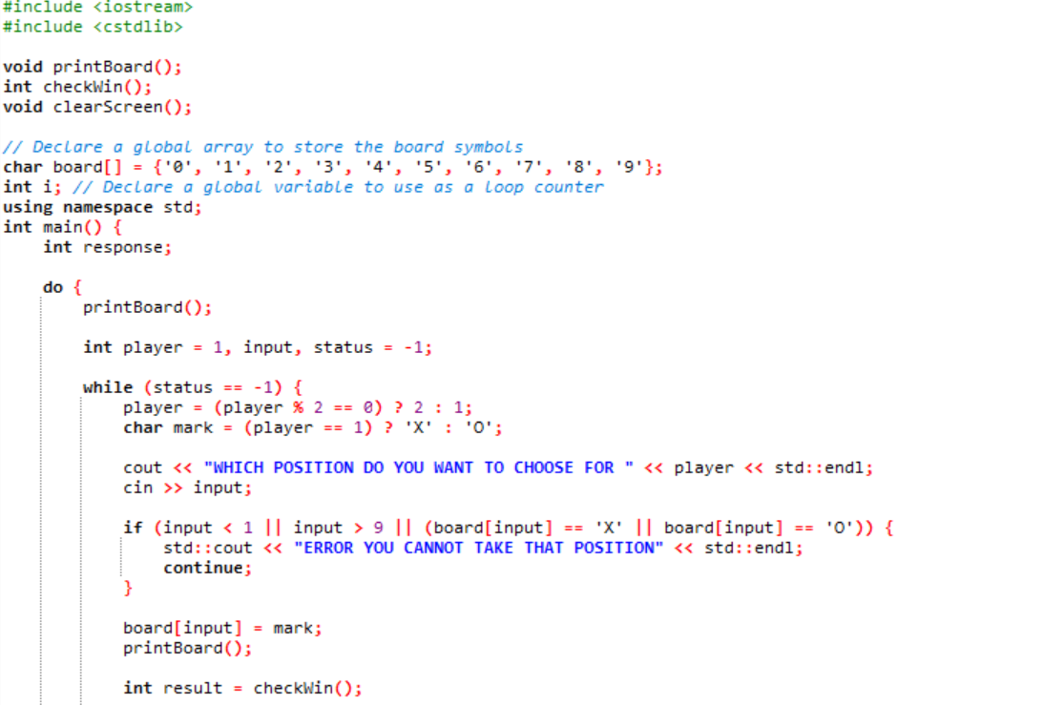

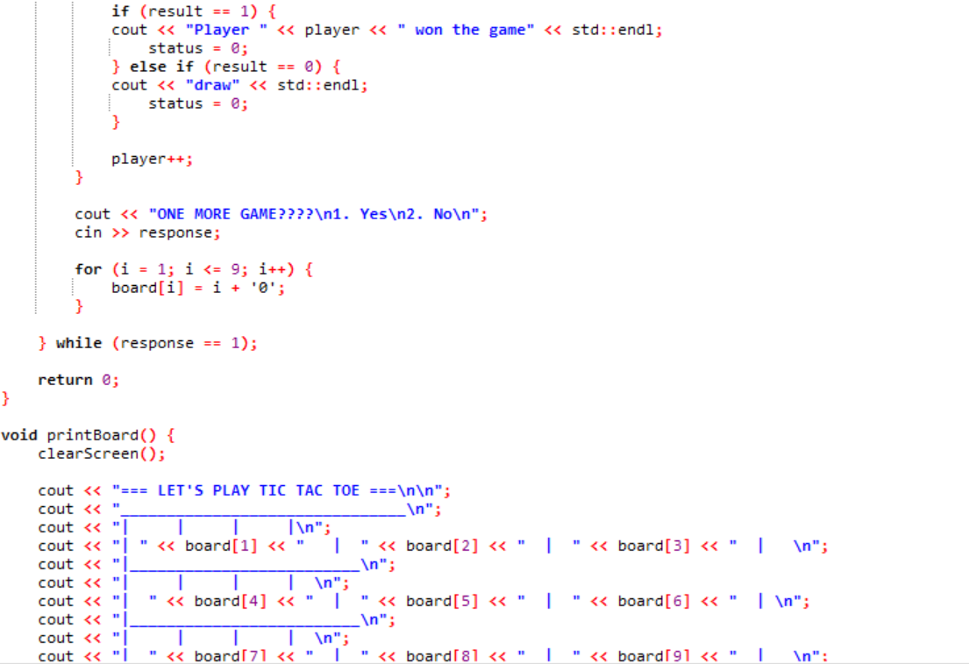

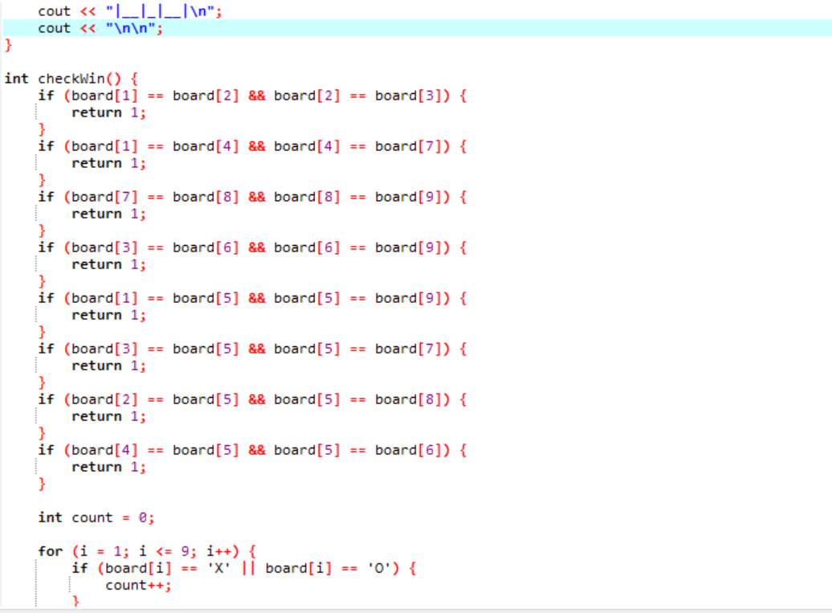

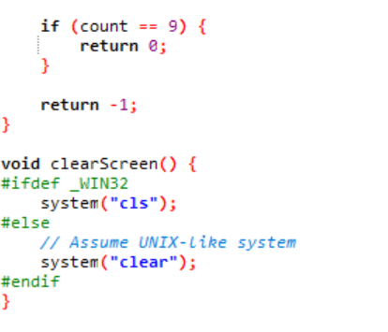

**OUTPUT:**

